EXPLAINABLE CLOUD THREAT INTELLIGENCE PLATFORM USING GRAPH NEURAL NETWORKS
School of Computer Science Engineering & Information Systems
Department of Information Technology | FALL SEMESTER 2026-27
BITE412L Cloud Computing Course Project — Review-I (Slot: A2)
NAME | REGISTRATION NUMBER
Akash S | 23BIT0379
Mugeshwaran E | 23BIT0307
Varsha K | 23BIT0347

1. Abstract
Modern cloud computing environments generate massive volumes of logs from network traffic, user authentication, and cloud resource activities. As cyberattacks become more sophisticated, traditional intrusion detection systems often struggle to identify multi-stage attacks because they analyze each event independently rather than considering the relationships between users, virtual machines, IP addresses, and cloud resources. Additionally, many existing deep learning models function as black boxes, making it difficult for security analysts to understand why a threat has been detected. This lack of transparency reduces trust in automated systems and increases the time required to investigate security incidents.
This project proposes an Explainable Cloud Threat Intelligence Platform using Graph Neural Networks (GNNs) to improve both threat detection accuracy and explainability. The platform transforms cloud telemetry, including network flow logs, Identity and Access Management (IAM) events, and resource activity logs, into a dynamic heterogeneous graph where nodes represent cloud entities and edges represent their interactions. A Graph Neural Network, such as GraphSAGE or Graph Attention Network (GAT), analyses these relationships to detect malicious activities by leveraging multi-hop contextual information that conventional machine learning models often fail to capture.
To enhance transparency, the platform integrates GNNExplainer, which identifies the most influential nodes and edges responsible for each prediction. Instead of providing only a threat score, the system generates a visual explanation in the form of a minimal subgraph, enabling security analysts to quickly understand the attack path and make informed decisions. The Graph Neural Network models are trained and evaluated using publicly available cybersecurity benchmark datasets, while the deployed platform continuously analyses real-time cloud telemetry generated within Microsoft Azure.
The proposed solution is implemented on Microsoft Azure using services such as Azure Event Hub for log ingestion, Azure Databricks for real-time graph construction, Azure Cosmos DB (Gremlin API) for graph storage, Azure Machine Learning for model training and inference, Azure Functions and Logic Apps for automated response workflows, and Microsoft Entra ID with Azure Key Vault for secure access management. By combining graph-based threat detection, explainable artificial intelligence, and cloud-native technologies, the platform aims to provide a scalable, accurate, and trustworthy cybersecurity solution for modern cloud environments.
2. Project Objectives
The primary objective of this project is to develop an Explainable Cloud Threat Intelligence Platform using Graph Neural Networks (GNNs) that can accurately detect sophisticated cyber threats in cloud environments while providing clear and interpretable explanations for every detected attack. The specific objectives of the project are as follows:
2.1 Model Cloud Telemetry as a Graph
Design and implement a heterogeneous graph model that integrates cloud telemetry data, including Identity and Access Management (IAM) logs, network flow logs, and resource activity logs. This graph-based representation captures the relationships among users, virtual machines, IP addresses, and cloud resources, enabling comprehensive threat analysis.
2.2 Develop a GNN-Based Threat Detection Model
Train and evaluate advanced Graph Neural Network models such as GraphSAGE and Graph Attention Networks (GAT) to perform node-level and edge-level threat classification. The model aims to improve detection accuracy and F1-score compared to traditional machine learning techniques by utilizing multi-hop relational information.
2.3 Integrate Explainable Artificial Intelligence (XAI)
Implement GNNExplainer to provide interpretable explanations for every detected threat. The explainability module identifies the most influential nodes and relationships responsible for the prediction, allowing security analysts to understand attack paths and make informed decisions quickly.
2.4 Build a Real-Time Threat Intelligence Pipeline
Develop a scalable streaming pipeline using Azure Event Hub and Azure Databricks to continuously ingest cloud telemetry, construct the entity graph, and update it in near real time for timely threat detection.
2.5 Ensure Secure and Scalable Deployment
Deploy the Graph Neural Network model using Azure Machine Learning while implementing secure access through Microsoft Entra ID, Azure Key Vault, and role-based access control (RBAC) to protect sensitive cloud resources and model endpoints.
2.6 Develop an Interactive Security Operations Dashboard
Design a user-friendly dashboard that visualizes the live cloud entity graph, highlighted threat subgraphs, explanation summaries, and security alerts. The dashboard enables analysts to monitor threats, investigate incidents efficiently, and initiate automated response workflows.
3. Novelty Summary
The proposed Explainable Cloud Threat Intelligence Platform using Graph Neural Networks (GNNs) introduces several innovative features that address the limitations of conventional cloud intrusion detection systems. Unlike traditional security solutions that analyze individual log entries or network flows independently, the proposed platform models the entire cloud environment as a connected entity graph and combines advanced Graph Neural Networks with Explainable Artificial Intelligence (XAI). The key novel contributions are detailed below:
3.1 Explainable Graph-Native Threat Modelling
Unlike conventional intrusion detection systems that treat each network flow or log entry independently, the proposed platform represents the complete cloud environment as a heterogeneous entity graph. Users, virtual machines, IP addresses, storage resources, and cloud services are modeled as nodes, while their interactions are represented as edges. The system integrates GNNExplainer to generate a minimal subgraph responsible for every detected threat, allowing security analysts to visualize attack paths and understand why a prediction was made instead of relying on unexplained threat scores.
3.2 Advanced Graph Neural Network-Based Detection
GraphSAGE and Graph Attention Networks (GAT) leverage neighborhood aggregation and attention mechanisms to capture multi-hop relationships among cloud entities. Traditional machine learning algorithms operate only on flat feature vectors and fail to capture complex contextual interactions. The proposed model detects sophisticated attacks such as lateral movement, privilege escalation, insider threats, and command-and-control communication.
3.3 Real-Time Streaming Graph Construction
Instead of creating static graphs through offline batch processing, the platform continuously constructs and updates the cloud entity graph using Azure Event Hub and Azure Databricks. Incoming telemetry data is processed in near real time, allowing the system to detect attacks as they occur and significantly reducing detection latency.
3.4 Native Azure Security Orchestration
The proposed architecture integrates Azure Functions and Azure Logic Apps to automate the complete incident response process. Once a threat is detected and explained, the platform automatically triggers Security Orchestration, Automation, and Response (SOAR) workflows such as isolating compromised virtual machines, revoking access tokens, or blocking malicious IP addresses without requiring third-party tools.
3.5 Zero-Trust Security Architecture
The platform adopts a Zero-Trust security model by implementing Microsoft Entra ID for role-based authentication and authorization, while Azure Key Vault securely manages API keys, access credentials, and sensitive configuration details. This ensures that only authenticated and authorized entities can access the graph database, AI models, and cloud infrastructure.
3.6 Automated Investigation Report Generation
To reduce the workload of Security Operations Centre (SOC) analysts, the platform automatically generates structured investigation reports for every detected threat. Each report includes the affected entities, attack path, confidence score, severity level, and explainable subgraph, accelerating incident response.
3.7 Threat Intelligence Generation
The proposed platform not only detects malicious activities but also correlates events across multiple cloud entities to identify attack paths, uncover relationships among compromised resources, and generate contextual threat intelligence for security analysts.
3.8 Scalable Distributed Graph Processing
The system employs Azure Databricks to perform distributed graph construction, feature aggregation, and large-scale data processing. This enables the platform to efficiently manage enterprise cloud environments containing thousands of users, virtual machines, and resources while maintaining high scalability.
4. Dataset Details
4.1 Dataset 1: Network Intrusion Detection (Primary Training Dataset)
- Dataset Name: CSE-CIC-IDS2018 (Canadian Institute for Cybersecurity Intrusion Detection System 2018)
- Source: Canadian Institute for Cybersecurity (CIC), University of New Brunswick
- URL: https://www.unb.ca/cic/datasets/ids-2018.html
- Size: Approximately 450 GB (uncompressed) containing over 16 million bidirectional network flow records.
- Number of Features: 80 flow-based network traffic features including source and destination IP addresses, ports, protocol, packet statistics, flow duration, TCP flags, and attack labels.
- Data Type: Structured network flow data (CSV format) generated using CICFlowMeter.
- License: Open for academic and research purposes through the Canadian Institute for Cybersecurity.
- Purpose: Serves as the primary training and evaluation dataset for the proposed Explainable Cloud Threat Intelligence Platform. It contains modern attack scenarios such as DDoS, DoS, Brute Force, Botnet, Web Attacks, and Infiltration.
- Preprocessing Required: Duplicate and incomplete record removal, missing/infinite value handling, categorical protocol encoding, feature normalization (Standard scaling), heterogeneous graph construction (entities as nodes, flows as edges), and train/val/test partitioning.
4.2 Dataset 2: Benchmark Network Security Dataset
- Dataset Name: UNSW-NB15
- Source: Australian Centre for Cyber Security (ACCS), University of New South Wales
- URL: https://research.unsw.edu.au/projects/unsw-nb15-dataset
- Size: Approximately 700 MB
- Number of Records: 2,540,044 network flow records
- Number of Features: 49 network traffic features, including Source IP, Destination IP, Ports, Protocol, State, Service, Packet Counts, Flow Duration, Transaction Details, and Attack Category.
- Data Type: Structured network traffic dataset (CSV format).
- License: Freely available for academic and research use through the ACCS.
- Purpose: Used as a benchmark dataset to validate the generalization capability and robustness of the GNN model across diverse attack categories.
- Preprocessing Required: Invalid record removal, missing value imputation, protocol/service categorical encoding, graph feature mapping, and dataset partitioning for validation.
5. Literature Survey
A comprehensive literature survey was conducted to evaluate state-of-the-art research in graph-based intrusion detection, explainable artificial intelligence (XAI), and cyber threat intelligence. The 15 benchmark papers are systematically analyzed below:
S.No. | Title of the Paper | Algorithm Used | Dataset Used | Performance Measures | Future Work
1 | Graph Neural Networks Embedded with Domain Knowledge for Cyber Threat Intelligence Entity and Relationship Mining (2025) | CtiErRe Model, Graph Convolutional Network (GCN), BERT, LayerNorm, GlobalPointer | Cyber Threat Intelligence (CTI) text dataset containing threat entities and relationships | Entity Recognition: Accuracy 92.13%, F1 93.11%, Precision 92.78%, Recall 93.44%.  Relationship Extraction: Accuracy 91.45%, F1 92.45%, Precision 92.34%, Recall 92.56%. | Improve domain knowledge representation, enhance relationship extraction accuracy, and support more complex cyber threat intelligence scenarios.
2 | A Novel Intelligent Cyber Threat Detection System with Blockchain-Enforced Immutable Forensic Auditability (2026) | CatBoost, Borderline-SMOTE, spaCy NER, Blockchain-based immutable logging, Confidence-aware anomaly detection | CICIDS-2017 and CTU-IoT-Malware-Capture datasets | CICIDS-2017: Accuracy 98.00%, F1 98.35%, MCC 0.960.  CTU-IoT-Malware: Accuracy 94.60%, F1 95.41%, MCC 0.892. Macro-AUC: 0.974. | Extension toward improved forensic explainability, rare attack detection, CTI integration, blockchain-enabled security auditing, and scalable deployment.
3 | How the Graph Construction Technique Shapes Performance in IoT Botnet Detection (2026) | Graph Attention Network (GAT), Variational Autoencoder (VAE), k-NN Graph, Mutual Nearest Neighbor Graph, Shared Nearest Neighbor Graph, Gabriel Graph, ε-radius Graph | N-BaIoT Dataset | Best performance obtained using Gabriel Graph with 97.56% accuracy. Lowest performance recorded by Shared Nearest Neighbor graph (78.56% accuracy). | Investigate additional graph construction techniques, improve graph generation strategies, and evaluate performance on diverse IoT attack datasets.
4 | Graph Attention Neural Network for Botnet Detection: Evaluating Autoencoder, VAE and PCA-Based Dimension Reduction (2025) | Graph Attention Network (GAT), Autoencoder (AE), Variational Autoencoder (VAE), Principal Component Analysis (PCA) | N-BaIoT IoT Botnet Dataset | Comparative evaluation of dimension-reduction techniques for GAT-based botnet detection. VAE-based latent representation produced the best overall detection performance. | Explore alternative graph neural architectures and scalable graph representations for large-scale IoT environments.
5 | XG-NID: Dual-Modality Network Intrusion Detection Using a Heterogeneous Graph Neural Network and Large Language Model (2024) | Heterogeneous Graph Neural Network (HGNN), Large Language Model (LLM), Graph-level Classification | Flow-level and packet-level network traffic represented as a heterogeneous graph structure | F1 Score: 97% in multi-class classification, outperforming baseline and state-of-the-art intrusion detection methods. | Improve real-time deployment, enhance explainability, expand graph representations, and strengthen automated remediation recommendations.
6 | Industrial Internet of Things Intrusion Detection System Based on Graph Neural Network (2025) | GraphSAGE, Long Short-Term Memory (LSTM) aggregator, Graph Neural Network (GNN), Mini-Batch Sampling, ReLU, Decision Tree, Random Forest, LCCDE, Anomal-E | BoT-IoT, ACI-IoT-2023, OPCUA | Binary Classification: Accuracy: 93.63% (BoT-IoT), 97.34% (ACI-IoT-2023), 100.00% (OPCUA); Precision: 98.29% (BoT-IoT), 98.75% (ACI-IoT-2023), 100.00% (OPCUA); Recall: 93.63% (BoT-IoT), 96.65% (ACI-IoT-2023), 100.00% (OPCUA); F1-Score: 94.34% (BoT-IoT), 97.68% (ACI-IoT-2023), 100.00% (OPCUA).  Multiclass Classification: Accuracy: 92.34% (BoT-IoT), 93.68% (ACI-IoT-2023), 99.99% (OPCUA); Precision: 94.86% (BoT-IoT), 94.92% (ACI-IoT-2023), 99.99% (OPCUA); Recall: 94.23% (BoT-IoT), 93.68% (ACI-IoT-2023), 99.99% (OPCUA); F1-Score: 94.55% (BoT-IoT), 94.12% (ACI-IoT-2023), 99.99% (OPCUA). | Optimize detection accuracy for specific attack categories like OS Scan by refining feature engineering and capturing high-order interaction patterns. Address performance constraints on small-sample scenarios.
7 | TE-G-SAGE: Explainable Edge-Aware Graph Neural Networks for Network Intrusion Detection (2025) | GraphSAGE (TE-G-SAGE), Graph Convolutional Network (GCN), XGBoost, Kernel SHAP, Spearman Rank Correlation | NF-UNSW-NB15-v3 | Binary Classification: Precision: 99.06%, Recall: 99.99%, F1-score: 99.52%, TNR: 99.91%, TPR: 99.99%, FAR: 0.09%.  Multiclass Macro Averages: Accuracy: 95.586%, Precision: 49.419%, Recall: 62.738%, F1-score: 48.40%, FAR: 0.446%, Micro AUC: 0.999. | Explore class-specific threshold calibration guided by precision-recall curves. Integrate edge gating, attention mechanisms, temporal contrastive pretraining, and degree-stratified analyses.
8 | Enhancing Multi-Class Attack Detection in Graph Neural Network through Feature Rearrangement (2024) | GraphSAGE, Edge-aware Message-Passing Neural Network (MPNN), E-GraphSAGE, Recurrent Neural Network (RNN), Support Vector Machine (SVM), UMAP | CIC-IDS-2017, UNSW-NB15 | Average Accuracy: 98.32% (CIC-IDS-2017), 96.71% (UNSW-NB15).  Overall Metrics: Precision: 97.20%, Recall: 96.60%, F1-score: 96.80%. | Evaluate proposed feature-rearranged GraphSAGE architecture across balanced network intrusion datasets to further assess class-specific detection performance.
9 | XAI-IDS: Toward Proposing an Explainable Artificial Intelligence Framework for Enhancing Network Intrusion Detection Systems (2024) | Random Forest (RF), Deep Neural Network (DNN), AdaBoost (ADA), K-Nearest Neighbor (KNN), Support Vector Machine (SVM), Multi-Layer Perceptron (MLP), LightGBM, SHAP, LIME | RoEduNet-SIMARGL2021, CICIDS-2017, NSL-KDD | RoEduNet-SIMARGL2021 (Top 15 Feat.): Acc: 99%, F1: 99%.  CICIDS-2017 (Top 15 Feat.): Acc: 99%, F1: 99%.  NSL-KDD (Top 15 Feat.): Acc: 88%, F1: 43%. | Incorporate automated explanation generation using generative AI, evaluate on additional benchmark datasets (UNSW-NB15, CTU-13), integrate human expert evaluations, and combine black-box and white-box XAI tools.
10 | Cyber security attack recognition on cloud computing networks based on graph convolutional neural network and graphsage models (2024) | GraphSAGE, Graph Convolutional Neural Network (GCN), Deep Neural Network Classifier, Adam Optimizer | CSE-CIC-IDS2018 | GraphSAGE: Accuracy: 97.739%, Loss: 0.1194, Precision: 99% (Benign), 95% (DoS), 99% (DDoS); Recall: 97% (Benign), 98% (DoS), 98% (DDoS); F1-Score: 98% (Benign), 97% (DoS), 98% (DDoS).  GCN: Accuracy: 80.151%, Loss: 0.4621. | Extend framework to larger scale live cloud streams, explore dynamic sub-graph pre-sampling techniques, and incorporate automated multi-flow anomaly response mechanisms.
11 | Botnet Node Detection Using Graph Learning (2026) | Heterogeneous Graph Neural Networks (HeteroGCN, HeteroGAT, HeteroSAGE, HeteroGAE), GraphSAGE, GCN, GAT, Graph Autoencoder (GAE) | TI-16 DNS-Labeled Dataset (Threat Intelligence 2016 DNS Dataset) | HeteroSAGE achieved Accuracy: 95.45%, F1-Score: 95.60%, Precision: 93.20%, Recall: 98.18%, AUC: 98.41%. HeteroGAE achieved Accuracy: 94.78%, F1-Score: 95.40%, Recall: 98.55%. High accuracy with low latency. | Evaluate on multiple heterogeneous datasets, perform hyperparameter optimization, investigate Transformer-based GNNs, improve scalability via partitioning, and study model quantization.
12 | LLM-powered Threat Intelligence: A Retrieval-Augmented Generation Approach for Cyber Attack Investigation (2025) | Retrieval-Augmented Generation (RAG), Hybrid Retrieval (BM25 + Dense Embeddings), FlashRank Reranking, Contextual Compression Retriever, FAISS Vector Store, Recursive Text Chunking, LLMs (GPT-4o Mini, GPT-3.5 Turbo, BART, Flan-T5) | MITRE ATT&CK Knowledge Base, CTI-ATE, CTI-TAA, CTI-ATTACK (339 attack investigation queries) | Evaluated via RAGAS metrics. GPT-4o achieved highest response relevancy (0.843 on CTI-ATE). Complete system processed datasets in ~6 hours. | Expand CTI knowledge base beyond MITRE ATT&CK, improve retrieval strategies for real-time threat analysis, strengthen resilience against knowledge poisoning attacks.
13 | Explainable AI for Federated Learning-Based Intrusion Detection Systems in Connected Vehicles (2025) | Federated Learning (FL), Deep Neural Network (DNN), FedAvg/Krum Aggregation, SHAP, LIME, Attention-based Feature Weighting, Federated Explainability Aggregation | CICEVSE2024 and CICIoV2024 connected vehicle intrusion detection datasets | Achieved 99.07% accuracy on CICEVSE2024 and 96.71% accuracy on CICIoV2024 with low false positive rates and improved convergence. | Secure explainability aggregation against malicious manipulation, develop security-aware explainability mechanisms, provide real-time feedback, and extend to multi-modal datasets.
14 | XMF-GNN: A Cross-Modality Dynamic Fusion Heterogeneous Graph Neural Network for Network Intrusion Detection (2025) | Cross-Modality Dynamic Fusion Heterogeneous Graph Neural Network (XMF-GNN), GraphSAGE-based HGNN, Attention-based Modality Fusion | CIC-IDS2017, CIC-IoT2023 | F1-score: 97.74% (CIC-IDS2017), 98.52% (CIC-IoT2023) for multi-class intrusion detection; binary classification F1-score up to 99.79%. | Extend to more multimodal datasets, improve robustness using adversarial training, enhance cross-domain transfer learning, integrate into automated online security platforms.
15 | Distributed Detection of Large-Scale Internet of Things Botnets Based on Graph Partitioning (2024) | Cluster-GCN, Graph Convolutional Network (GCN), METIS Graph Partitioning, GNNExplainer | C2, P2P, Chord (derived from CTU-13 botnet dataset) | Achieved 99.978% accuracy, 99.74% F1-score, 99.66% precision on C2 dataset with efficient distributed detection. | Validate on more diverse real-world datasets, support hybrid botnets, improve generalization, deploy in practical IoT environments.

6. Threat Categories
The proposed platform is specifically designed and trained to detect multiple categories of cyber threats across cloud environments, including:
- Distributed Denial-of-Service (DDoS): Simultaneous high-volume traffic flooding originating from multiple external host vectors targeting cloud services.
- Distributed Reflection DoS (DrDoS): Amplified reflection attack vectors exploiting third-party misconfigured UDP services.
- Brute Force Attacks: Automated credential stuffing and dictionary attacks against SSH, RDP, and Entra ID authentication endpoints.
- Botnet Activity: Infected host entities executing automated scripts and maintaining command-and-control (C2) communication channels.
- Port Scanning: Systematic probing of TCP/UDP ports and network endpoints to identify vulnerable running services.
- Web Attacks: Exploitation of web application vulnerabilities including SQL Injection, Cross-Site Scripting (XSS), and Remote Code Execution.
- Infiltration: Unidentified compromise of internal network nodes or perimeter defense bypass.
- Reconnaissance: Active mapping of internal cloud topology, active resource discovery, and service enumerations.
- Privilege Escalation: Unauthorized acquisition of elevated administrative privileges or role bindings within Microsoft Entra ID.
- Lateral Movement: Adversarial movement across compromised virtual instances, storage accounts, and internal cloud subnets.
7. Proposed Architecture
7.1 Azure Cloud Infrastructure Architecture
The enterprise cloud deployment architecture is designed around Microsoft Azure native services within a secure Virtual Network (VNet) boundary. The complete platform architecture is illustrated below:
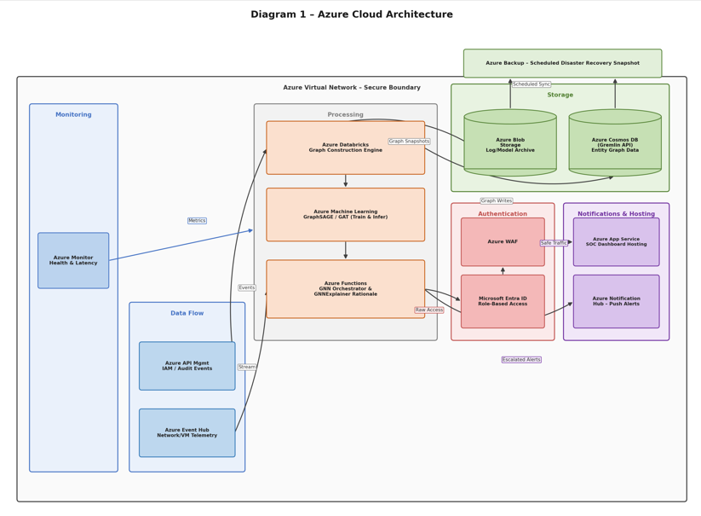
Figure 1: shows the Azure-based architecture of the proposed Explainable Cloud Threat Intelligence Platform. The workflow is as follows:
This diagram shows how individual Azure services interact within a secure Virtual Network boundary to support the Explainable Cloud Threat Intelligence Platform.
Data Flow
Two entry points feed the system: Azure Event Hub ingests network and VM-level telemetry (flow logs, syslogs), while Azure API Management ingests IAM and audit events (sign-ins, role changes, resource access). Both streams flow into the Processing layer, where they are unified.
Processing
This is the analytical core of the platform:
- Azure Databricks consumes the incoming telemetry and constructs the heterogeneous entity graph — turning users, VMs, IPs, and resources into nodes, and their interactions into edges.
- Azure Machine Learning hosts the GraphSAGE/GAT model, which is trained on this graph and used for real-time inference to classify malicious nodes and edges.
- Azure Functions acts as the orchestrator: it receives model output, applies the GNNExplainer logic to generate a subgraph rationale for each flagged threat, and decides what happens next (authentication check, alert, or dismissal).
Storage
The constructed graph is persisted in Azure Cosmos DB (Gremlin API), while raw logs, graph snapshots, and trained model artifacts sit in Azure Blob Storage. Both are synced on a schedule to Azure Backup for disaster recovery — this keeps the platform's historical data recoverable even if the primary graph store is compromised or corrupted.
Authentication
Before any user-facing action is taken, requests pass through Azure WAF (blocking web-layer attacks like injection/XSS) and Microsoft Entra ID, which enforces role-based access control so only authorized SOC analysts and services can query the graph or trigger responses.
Notifications & Hosting
Once traffic is authenticated, Azure App Service hosts the SOC dashboard itself, and Azure Notification Hub pushes escalated alerts out to the response channel (analyst devices, on-call systems).
Monitoring
Azure Monitor sits outside the main pipeline and continuously watches the Processing layer — tracking ingestion throughput, model latency, and graph update health — so operational issues in the detection pipeline are caught independently of the threat-detection logic itself.

7.2 Complete System Workflow Architecture
The end-to-end data processing, feature engineering, graph construction, AI inference, and automated mitigation workflow is illustrated in Figure 2 below:
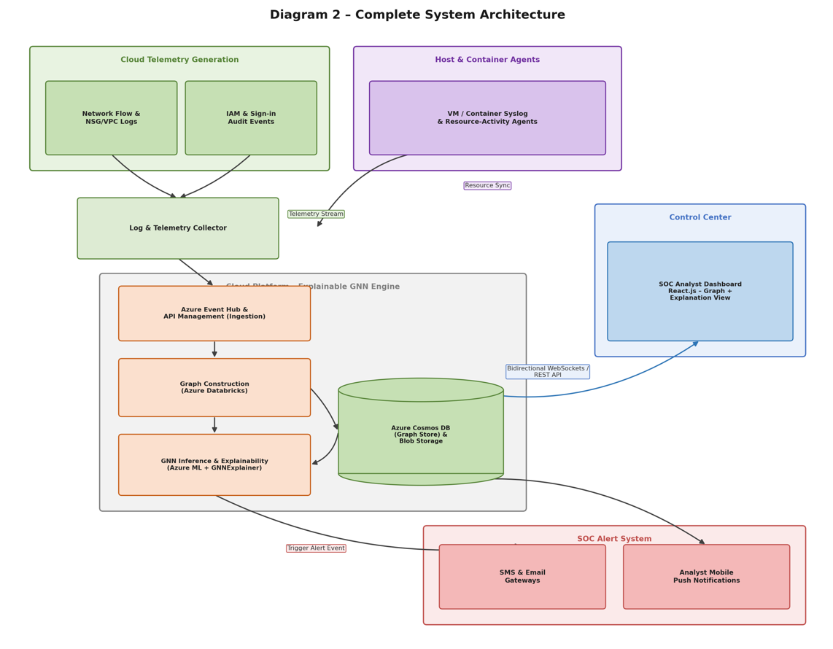
Figure 2: illustrates the end-to-end workflow of the proposed platform.
This diagram traces the full lifecycle of a security event, from raw telemetry to a resolved alert.
- Cloud Telemetry Generation — Network flow/NSG logs and IAM sign-in events are generated continuously by the monitored cloud tenancy.
- Host & Container Agents — In parallel, VM and container-level syslog agents capture resource-activity data directly from compute workloads, syncing it into the same pipeline.
- Log & Telemetry Collector — Both channels converge here, where logs are normalized before being handed to the detection engine.
- Cloud Platform – Explainable GNN Engine — This is the heart of the system:
  - Azure Event Hub/API Management ingest the normalized telemetry.
  - Azure Databricks builds the live entity graph from it.
  - Azure ML + GNNExplainer run inference and generate a human-readable subgraph explanation for anything flagged.
  - The Cosmos DB/Blob graph store sits alongside this engine, both feeding data into inference and receiving newly constructed graph snapshots.
- Control Center — The SOC Analyst Dashboard connects bidirectionally to the graph store (via WebSockets/REST API), letting analysts explore the live graph and the explanation behind any flagged threat, not just a raw score.
- SOC Alert System — When the GNN engine flags a threat, it triggers alerts that are routed two ways: SMS/Email gateways for broader notification, and push notifications directly to the analyst's device for immediate triage.
The overall narrative: telemetry becomes a graph, the graph produces an explained prediction (not a black-box score), and that explanation is what reaches both the dashboard and the alerting system — which is the core novelty of your project.

8. Performance Evaluation Metrics
To rigorously evaluate the performance, detection capabilities, and real-time operational efficiency of the proposed platform, the following evaluation metrics will be measured:
- Accuracy: Measures the overall percentage of correctly classified normal and threat events across the complete test dataset.
- Precision: Evaluates the proportion of true positive threat detections among all alerts generated by the model, minimizing false alarms.
- Recall (Sensitivity): Measures the capability of the platform to successfully detect all actual cyber threat events present in the cloud environment.
- F1-Score: The harmonic mean of Precision and Recall, providing a reliable measure of model performance on highly imbalanced threat datasets.
- ROC-AUC: Evaluates the model's classification performance across varying discrimination thresholds.
- Detection Rate: Percentage of total malicious attacks successfully identified across various threat categories.
- False Positive Rate (FPR): The frequency with which legitimate user or network activities are incorrectly flagged as malicious threats.
- Inference Latency: The elapsed execution time required by the GNN model and GNNExplainer module to perform threat scoring and subgraph extraction.
- Graph Processing Time: End-to-end processing duration required to ingest raw telemetry, construct the heterogeneous graph, and persist update nodes in Cosmos DB.
9. Azure Services Planning
The table below details the cloud-native Microsoft Azure services integrated into the Explainable Cloud Threat Intelligence Platform and their specific functional roles across the pipeline:
Azure Service | Purpose in the Explainable Cloud Threat Intelligence Platform
Azure Event Hub | Ingest real-time Azure Activity Logs, NSG Flow Logs, and Microsoft Entra ID Sign-in Logs from the monitored cloud environment.
Azure Databricks | Perform distributed, streaming construction of the heterogeneous entity graph from ingested telemetry.
Azure Cosmos DB (Gremlin API) | Store and query the live cloud-entity graph (users, VMs, IPs, resources, and their relationships).
Azure Machine Learning | Train, evaluate, and serve the GraphSAGE / GAT model for node- and edge-level threat classification.
Azure Functions | Orchestrate alert logic — evaluate model output, apply severity thresholds, and trigger downstream workflows.
Azure Logic Apps | Automate SOAR-style response actions such as ticket creation, isolation requests, and escalation routing.
Microsoft Entra ID (Azure AD) | Provide zero-trust, role-based authentication and access control for analysts and platform services.
Azure Key Vault | Securely store API keys, model endpoint credentials, and connection secrets used across the pipeline.
Azure Blob Storage | Archive raw log data, historical graph snapshots, and trained model artefacts for retraining and audit.
Azure Notification Hubs | Deliver real-time push, SMS, and Teams/email alerts to on-call security analysts.
Azure Web Application Firewall (WAF) | Protect the analyst-facing dashboard and API endpoints from web-based attacks such as SQL Injection and XSS.
Azure Virtual Network (VNet) | Provide a private, isolated network boundary for secure communication between all platform services.
Azure Monitor | Continuously track ingestion throughput, graph update latency, inference time, and overall platform health.
Azure Backup | Automatically back up the Cosmos DB graph store and Blob Storage archives for disaster recovery.

10. Future Scope
Future enhancements to the platform include integrating Large Language Models (LLMs) for automated incident summarization, federated graph learning for multi-cloud deployments, and dynamic MITRE ATT&CK mapping to further improve threat investigation and automated response capabilities.
11. References
- Liu, G., Lu, K., & Pi, S. (2025). Graph neural networks embedded with domain knowledge for cyber threat intelligence entity and relationship mining. PeerJ Computer Science, 11, e2769. https://doi.org/10.7717/peerj-cs.2769
- Mishra, S., Alyousef, O. A., & Alodhyani, F. (2026). A novel intelligent cyber threat detection system with blockchain-enforced immutable forensic auditability. PeerJ Computer Science, 12, e3803. https://doi.org/10.7717/peerj-cs.3803
- Wasswa, H., Abbass, H., & Lynar, T. (2026). How the graph construction technique shapes performance in IoT botnet detection. arXiv. https://doi.org/10.48550/arXiv.2603.06654
- Wasswa, H., Abbass, H., & Lynar, T. (2025). Graph attention neural network for botnet detection: Evaluating autoencoder, VAE and PCA-based dimension reduction. arXiv. https://doi.org/10.48550/arXiv.2505.17357
- Farrukh, Y. A., Wali, S., Khan, I., & Bastian, N. D. (2024). XG-NID: Dual-modality network intrusion detection using a heterogeneous graph neural network and large language model. arXiv. https://doi.org/10.48550/arXiv.2408.16021
- Yang, S., Pan, W., Li, M., Yin, M., Ren, H., Chang, Y., Liu, Y., Zhang, S., & Lou, F. (2025). Industrial Internet of Things Intrusion Detection System Based on Graph Neural Network. Symmetry, 17(7), 997. https://doi.org/10.3390/sym17070997
- Luša, R., Pintar, D., & Vranić, M. (2025). TE-G-SAGE: Explainable Edge-Aware Graph Neural Networks for Network Intrusion Detection. Modelling, 6(4), 165. https://doi.org/10.3390/modelling6040165
- Le, H.-D., & Park, M. (2024). Enhancing Multi-Class Attack Detection in Graph Neural Network through Feature Rearrangement. Electronics, 13(12), 2404. https://doi.org/10.3390/electronics13122404
- Arreche, O., Guntur, T., & Abdallah, M. (2024). XAI-IDS: Toward Proposing an Explainable Artificial Intelligence Framework for Enhancing Network Intrusion Detection Systems. Applied Sciences, 14(10), 4170. https://doi.org/10.3390/app14104170
- Abdullayeva, F., & Suleymanzade, S. (2024). Cyber security attack recognition on cloud computing networks based on graph convolutional neural network and graphsage models. Results in Control and Optimization, 15, 100423. https://doi.org/10.1016/j.rico.2024.100423
- Karyağdı, G., & Özçelik, İ. (2026). Botnet Node Detection Using Graph Learning. Applied Sciences, 16(1), 24. MDPI. https://doi.org/10.3390/app16010024
- Alhuzali, A. (2025). LLM-powered Threat Intelligence: A Retrieval-Augmented Generation Approach for Cyber Attack Investigation. PeerJ Computer Science, 11:e3371. https://doi.org/10.7717/peerj-cs.3371
- Taheri, R., Jafari, R., Gegov, A., Arabikhan, F., & Ichtev, A. (2025). Explainable AI for Federated Learning-Based Intrusion Detection Systems in Connected Vehicles. Electronics, 14(22), 4508. https://doi.org/10.3390/electronics14224508
- Ma, Z., Liu, Y., Chen, Y., Liu, Z., & Li, Y. (2025). XMF-GNN: A Cross-Modality Dynamic Fusion Heterogeneous Graph Neural Network for Network Intrusion Detection. Neurocomputing, 655, 131285. https://doi.org/10.1016/j.neucom.2025.131285
- Qian, K., Yang, H., Li, R., Chen, W., Luo, X., & Yin, L. (2024). Distributed Detection of Large-Scale Internet of Things Botnets Based on Graph Partitioning. Applied Sciences, 14(4), 1615. https://doi.org/10.3390/app14041615

